Ideation Phase

Define the Problem Statements

Date | 31 January 2026
Team ID | LTVIP2026TMIDS24102
Project Name | Heritage Treasures: An In-Depth Analysis of UNESCO World Heritage Sites in Tableau
Maximum Marks | 2 Marks

Customer Problem Statement Template:

“Researchers, heritage professionals, and educators need an interactive and visual way to explore UNESCO World Heritage Site data because the current raw format is difficult to interpret, limiting their ability to analyse trends, identify regional insights, and make informed decisions.”

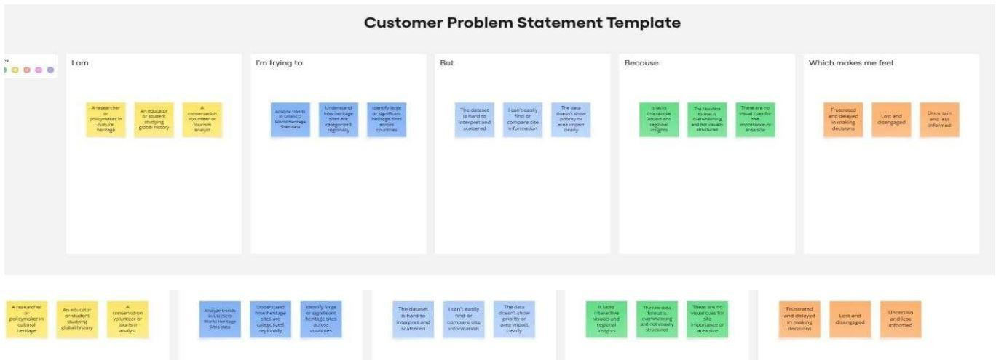

Problem Statement (PS) | I am (Customer) | I’m trying to | But | Because | Which makes me feel
PS-1 | A researcher or policymaker in heritage studies | Analyse trends in UNESCO  World Heritage Sites data | The dataset is raw and hard to visualize | It lacks interactivity and insight driven summaries | Frustrated and delayed in making decisions
PS-2 | An educator or student exploring global heritage | Understan d the regional and category- wise distributio n | It’s hard to extract patterns from Spread sheets | The data isn’t structured for easy exploration or comparison | Overwhelm ed and confused

